**Fabian LeFevre**

**SUBMISSION REQUIREMENTS / HOMEWORK:**

There are only two screenshots necessary from the lab and can be shared if you’re working in a group. **The homework must be done separately, and is a mix of practical/theoretical questions from recent classes.**

1. (20 points) Copy and paste the **two screenshots**from your lab:

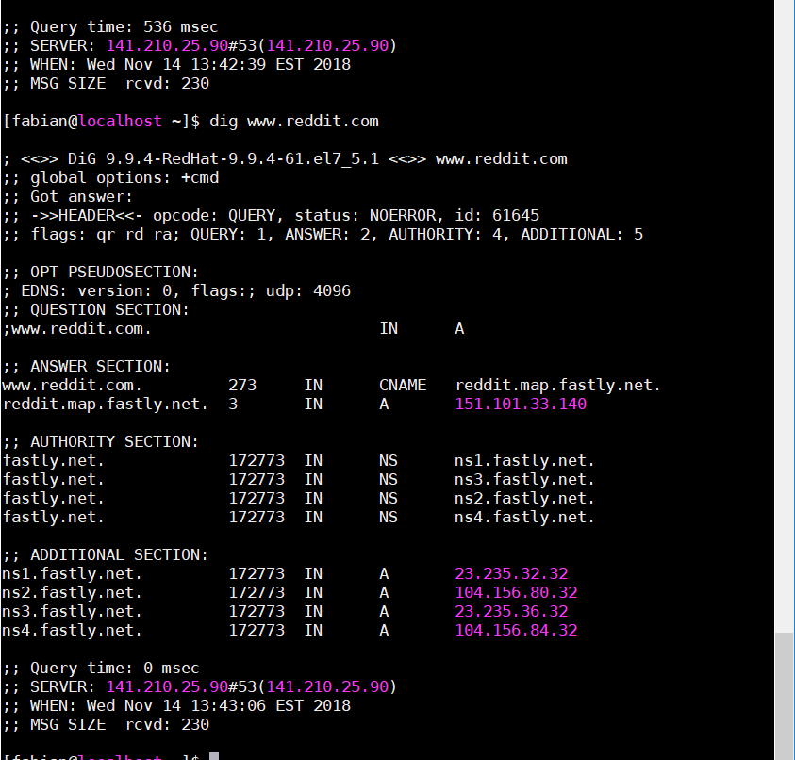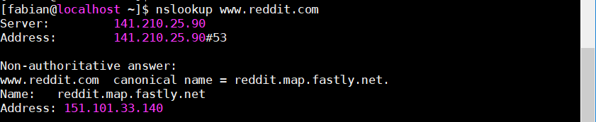

1. (4 points) What is the purpose of running a DNS cache server, and what risk do you run from having a cache server?

**A DNS cache server allows for faster access to web services and web sites by storing known locations in the cache that gets referenced when network services are used.**

**Risks you can have from using a cache server are cache poisoning and other security risks.**

*For Questions (3) and (4), assume we have an IP address of 141.100.25.4 and a subnet mask of 255.255.0.0*

1. (2 points) What is the network portion of the IP address above?

**141.100.0.0**

1. (2 points) What is the host portion of the IP address above?

**0.0.25.4**

**Host address range: 141.100.0.1 to 141.100.255.254**

1. (2 points) Assume a subnet mask of 255.255.0.0. What happens when a packet is sent to 192.168.255.255?

**The packet is broadcasted onto the 192.168.0.0 network.**

1. (2 points) What is the purpose of **chroot**?

**Change the root directory of a command or interactive shell.**

1. (6 points) What are the differences between the 3 NTP strata?

**The 3 NTP Strata are:**

* **Stratum 0**

**Has the atomic clock or GPS clock. Used as the reference clock.**

* **Stratum 1**

**Obtains time directly from strata 0 device. Is directly connected to the reference clock.**

* **Stratum 2**

**Obtains time directly from the strata 1 device. Connected to strata 1 via a network connection.**

1. (2 points) What is the current status of your term project?

**Gmod server project currently has SteamCMD and httpd installed. TF2 content and the update_gmod.sh bash file added. Need to figure out how to have a remote user access and join the server.**